



# Incident Response Platform Integrations

# LDAP Utilities V1.1.0

Release Date: April 2019

Resilient Functions simplify development of integrations by wrapping each activity into an individual workflow component. These components can be easily installed, then used and combined in Resilient workflows. The Resilient platform sends data to the function component that performs an activity then returns the results to the workflow. The results can be acted upon by scripts, rules, and workflow decision points to dynamically orchestrate the security incident response activities.

This guide describes the LDAP Utility Functions.

Overview

The Lightweight Directory Access Protocol, or LDAP, is an open, vendor-neutral, industry standard application protocol for accessing and maintaining distributed directory information services over an IP network. It is used to connect to, search, and modify internet directories.

These LDAP Utility integrations with the IBM Resilient platform allow multiple LDAP tasks to be initiated from the Resilient platform to an external LDAP server. The returned results can be used to make customized updates to the Resilient platform such as updating incidents, artifacts, data tables and so on.

These LDAP Utility Functions integration package contains several useful workflow functions for common automation and integration activities in the Resilient platform.

This document describes each utility function, how to configure it in custom workflows, and any additional customization options.

Installation

Before installing, verify that your environment meets the following prerequisites:

* Resilient platform is version 30 or later.
* You have a Resilient account to use for the integrations. This can be any account that has the permission to view and modify administrator and customization settings, and read and update incidents. You need to know the account username and password.
* You have access to the command line of the Resilient appliance, which hosts the Resilient platform; or to a separate integration server where you will deploy and run the functions code. If using a separate integration server, you must install Python version 2.7.10 or later, or version 3.6 or later, and “pip”. (The Resilient appliance is preconfigured with a suitable version of Python.)

Install the Python components

The functions package contains Python components that are called by the Resilient platform to execute the functions during your workflows. These components run in the Resilient Circuits integration framework.

The package also includes Resilient customizations that will be imported into the platform later.

Complete the following steps to install the Python components:

1. Ensure that the environment is up-to-date, as follows:

sudo pip install --upgrade pip

sudo pip install --upgrade setuptools

sudo pip install --upgrade resilient-circuits

1. Run the following command to install the package:

sudo pip install --upgrade fn_ldap_utilities-1.0.0.zip

Configure the Python components

The Resilient Circuits components run as an unprivileged user, typically named integration. If you do not already have an integration user configured on your appliance, create it now.

Complete the following steps to configure and run the integration:

1. Using sudo, switch to the integration user, as follows:

sudo su - integration

1. Use one of the following commands to create or update the resilient-circuits configuration file. Use –c for new environments or –u for existing environments.

resilient-circuits config -c

or

resilient-circuits config -u

1. Edit the resilient-circuits configuration file, as follows:
   1. In the [resilient] section, ensure that you provide all the information required to connect to the Resilient platform.
   2. In the [fn_ldap_utilities] section, for a **non-encrypted connection** to either **Active Director or OpenLDAP** edit the settings as follows:

[fn_ldap_utilities]

ldap_server=[*ip address of your LDAP Server*]

ldap_port=389

ldap_use_ssl=False

ldap_auth=SIMPLE [*Can be ANONYMOUS, SIMPLE, NTLM or SASL*]

ldap_user_dn=CN=Username,CN=Users,DC=example,DC=com [*DN of LDAP master account*]

# ldap_user_ntlm=Domain\\User

ldap_password=[*Password for the master LDAP account]*

ldap_is_active_directory=False

ldap_connect_timeout=10

* 1. For an **encrypted connection over SSL to an Active Directory Server**, edit the settings as follows:

[fn_ldap_utilities]

ldap_server=[*ip address of your LDAP Server*]

ldap_port=636

ldap_use_ssl=True

ldap_auth=SIMPLE

ldap_user_dn=CN=Username,CN=Users,DC=example,DC=com

ldap_user_ntlm=Domain\\User

ldap_password=[*Password for the master LDAP account]*

ldap_is_active_directory=True

ldap_connect_timeout=10

Deploy customizations to the Resilient platform

The package contains function definitions that you can use in workflows, and includes example workflows and rules that show how to use these functions.

1. Use the following command to deploy these customizations to the Resilient platform:

resilient-circuits customize

1. Respond to the prompts to deploy functions, message destinations, workflows and rules.

Run the integration framework

To test the integration package before running it in a production environment, you must run the integration manually with the following command:

resilient-circuits run

The resilient-circuits command starts, loads its components, and continues to run until interrupted. If it stops immediately with an error message, check your configuration values and retry.

Configure Resilient Circuits for restart

For normal operation, Resilient Circuits must run continuously. The recommended way to do this is to configure it to automatically run at startup. On a Red Hat appliance, this is done using a systemd unit file such as the one below. You may need to change the paths to your working directory and app.config.

1. The unit file must be named resilient_circuits.service To create the file, enter the following command:

sudo vi /etc/systemd/system/resilient_circuits.service

1. Add the following contents to the file and change as necessary:

[Unit]  
Description=Resilient-Circuits Service  
After=resilient.service  
Requires=resilient.service

[Service]  
Type=simple  
User=integration  
WorkingDirectory=/home/integration  
ExecStart=/usr/local/bin/resilient-circuits run  
Restart=always  
TimeoutSec=10  
Environment=APP_CONFIG_FILE=/home/integration/.resilient/app.config  
Environment=APP_LOCK_FILE=/home/integration/.resilient/resilient_circuits.lock

[Install]  
WantedBy=multi-user.target

1. Ensure that the service unit file is correctly permissioned, as follows:

sudo chmod 664 /etc/systemd/system/resilient_circuits.service

1. Use the systemctl command to manually start, stop, restart and return status on the service:

sudo systemctl resilient_circuits [start|stop|restart|status]

Function Descriptions

Once the function package deploys the functions, you can view them in the Resilient platform Functions tab, as shown below. The package also includes example workflows and rules that show how the functions can be used. You can copy and modify these workflows and rules for your own needs.

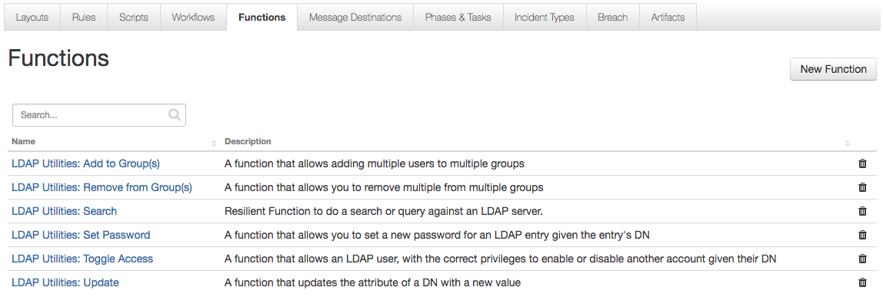

LDAP Utilities: Add to Groups

This function allows adding any number of accounts to multiple groups.

**Supports:** Active Directory only

**Inputs:**

|  |  |  |
| --- | --- | --- |
| **Name** | **Type** | **Example** |
| ldap_multiple_user_dn | String representation of a List | "['dn=tom smith,dc=example,dc=com', 'dn=ted smith,dc=example,dc=com']" |
| ldap_multiple_group_dn | String representation of a List | "['dn=Group1,dc=example,dc=com', 'dn=Group1,dc=example,dc=com']" |

**Output:**

|  |  |  |
| --- | --- | --- |
| **Name** | **Type** | **Description** |
| results.success | Boolean | True if users successfully added to groups; otherwise, False. |
| results.users_dn | List | List of users added to the groups. |
| results.groups_dn | List | List of groups where users were added. |

**Condition:** The user and group DNs must be valid.

LDAP Utilities: Remove from Groups

This function allows removing any number of accounts from multiple groups.

**Supports:** Active Directory only

**Inputs:**

|  |  |  |  |
| --- | --- | --- | --- |
| **Name** | **Type** | **Required** | **Example** |
| ldap_multiple_user_dn | String representation of a List | Yes | "['dn=tom smith,dc=example,dc=com', 'dn=ted smith,dc=example,dc=com']" |
| ldap_multiple_group_dn | String representation of a List | Yes | "['dn=Group1,dc=example,dc=com',  'dn=Group2,dc=example,dc=com']" |

**Output:**

|  |  |  |
| --- | --- | --- |
| **Name** | **Type** | **Description** |
| results.success | Boolean | True if users successfully removed from the groups; otherwise, False. |
| results.users_dn | List | List of users removed from the groups. |
| results.groups_dn | list | List of groups that had users removed. |

**Conditions:**

* The group DNs must be valid.
* Only valid user DNs are removed from the groups. Any user DN that is not a member of the group or is invalid is ignored.

LDAP Utilities: Search

The function runs a search query against an LDAP server.

**Supports:** Active Directory and OpenLDAP

**Inputs:**

|  |  |  |  |
| --- | --- | --- | --- |
| **Name** | **Type** | **Required** | **Example** |
| ldap_search_base | String | Yes | "dc=example,dc=com" |
| ldap_search_filter | String | Yes | "(&(objectClass=person)(mail=%ldap_param%))" |
| ldap_search_attributes | String | No | "uid,cn,sn,mail,telephoneNumber" |
| ldap_search_param | String | No | "Einstein" |

**Output:**

|  |  |  |
| --- | --- | --- |
| **Name** | **Type** | **Description** |
| results.success | Boolean | True if at least one entry was found. |
| results.entries | List | List of entries returned from LDAP. Each entry will always contain the DN Attribute. Each entry is a Dictionary with the Key being the Attribute and the Value being the Attributes Value. Note: Some Attribute Values can be a List. |

**Conditions:**

* The search_base and search_filter must be valid.
* If the %ldap_param% wildcard is used in the search_filter, the search_param input is required.

**Additional Configuration (only for Workflow - Example: LDAP Utilities: Search):**

To display query results, users need to manually add the “LDAP Query results” data table to the Artifacts tab.

1. Navigate to the Customization Settings and select the **Layouts** tab.
2. Select **Artifacts**.
3. Drag the **LDAP Query results** data table to your Artifacts tab.
4. Click **Save**.

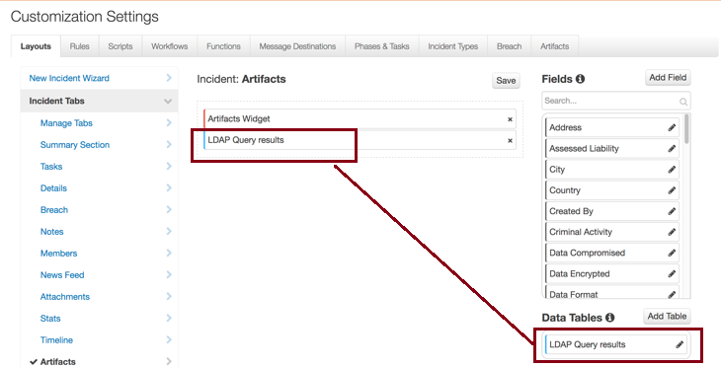

LDAP Utilities: Set Password

This function allows you to set a new password for a given user.

**Supports:** Active Directory and OpenLDAP

**Inputs:**

|  |  |  |  |
| --- | --- | --- | --- |
| **Name** | **Type** | **Required** | **Example** |
| ldap_dn | String | Yes | "dn=tom smith,dc=example,dc=com" |
| ldap_new_password | String | Yes | "newpassword123" |

**Output:**

|  |  |  |
| --- | --- | --- |
| **Name** | **Type** | **Description** |
| results.success | Boolean | True if user passwords were successfully changed. |
| results.user.dn | String | DN of the user whose password was changed. |

**Condition:** User DN must be valid.

LDAP Utilities: Toggle Access

This function allows enabling and disabling of an Active Directory account.

**Supports:** Active Directory only

**Inputs:**

|  |  |  |  |
| --- | --- | --- | --- |
| **Name** | **Type** | **Required** | **Example** |
| ldap_dn | String | Yes | "dn=tom smith,dc=example,dc=com" |
| ldap_toggle_access | Select | Yes | Enable/Disable [Pick from Dropdown] |

**Output:**

|  |  |  |
| --- | --- | --- |
| **Name** | **Type** | **Description** |
| results.success | Boolean | True if user was successfully Enabled or Disabled. |
| results.user.dn | String | DN of the user whose access was changed. |
| results.user_status | String | Will be Enabled or Disabled. |

**Condition:** User DN must be valid.

LDAP Utilities: Update

This function updates the attribute of a DN with a new value.

**Supports:** Active Directory and OpenLDAP

**Inputs:**

|  |  |  |  |
| --- | --- | --- | --- |
| **Name** | **Type** | **Required** | **Example** |
| ldap_dn | String | Yes | "dn=tom smith,dc=example,dc=com" |
| ldap_attribute_name | String | Yes | "mail" |
| ldap_attribute_values | String representation of a List | Yes | "['email1@example.com', 'email2@emample.com']" |

**Output:**

|  |  |  |
| --- | --- | --- |
| **Name** | **Type** | **Description** |
| results.success | Boolean | True if user attributes were successfully updated. |
| results.user.dn | String | DN of the user whose attribute was updated. |
| results.attribute_name | String | Name of the attribute updated. |
| results.attribute_values | String representation of a List | List of the attribute’s updated values. |

**Conditions:**

* User DN must be valid.
* Attribute Name must be valid.
* The Attribute Values must meet the Custom Constraints set on your LDAP server.

Troubleshooting

There are several ways to verify the successful operation of a function.

* Resilient Action Status

When viewing an incident, use the Actions menu to view Action Status. By default, pending and errors are displayed. Modify the filter for actions to also show Completed actions. Clicking on an action displays additional information on the progress made or what error occurred.

* Resilient Scripting Log

A separate log file is available to review scripting errors. This is useful when issues occur in the pre-processing or post-processing scripts. The default location for this log file is: /var/log/resilient-scripting/resilient-scripting.log.

* Resilient Logs

By default, Resilient logs are retained at /usr/share/co3/logs. The client.log may contain additional information regarding the execution of functions.

* Resilient-Circuits

The log is controlled in the .resilient/app.config file under the section [resilient] and the property logdir. The default file name is app.log. Each function will create progress information. Failures will show up as errors and may contain python trace statements.

Support

For additional support, contact [support@resilientsystems.com](mailto:support@resilientsystems.com).

Including relevant information from the log files will help us resolve your issue.